https://www.youtube.com/watch?v=BM6QiOKcfdQ
winkeyfinder
http://rudyr.free.fr/installation%20sp%201%20pour%20xp.htm

https://fr.wikihow.com/activer-Windows-XP-sans-la-cl%C3%A9-originale-du-produit

Windows loader 2.1.7 by daz

http://ftpnomade2.free.fr/Microsoft/Windows/Windows%20XP%20with%20SP3%20Integrated%20VOL%20MSDN%20(x86)%20fran%E7ais/info.txt

fr_windows_xp_professional_with_service_pack_3_x86_cd_vl_x14-73982.iso

http://auto-download.com/download/get/sdYEDXrkce/fr_windows_xp_professional_with_service_pack_3_x86_cd_vl_x14-73982_iso.html
OK marche

Windows XP Professional SP3 VLK (Corporate) keys:

BHBCB-PTHCD-C7K3K-HFPVC-4BB78
THMPV-77D6F-94376-8HGKG-VRDRQ

642ce8f1a31bdd118d617ff2fe037c26

OK
HQXPH-QWDPC-C4CQ8-MRDRD-9HF23

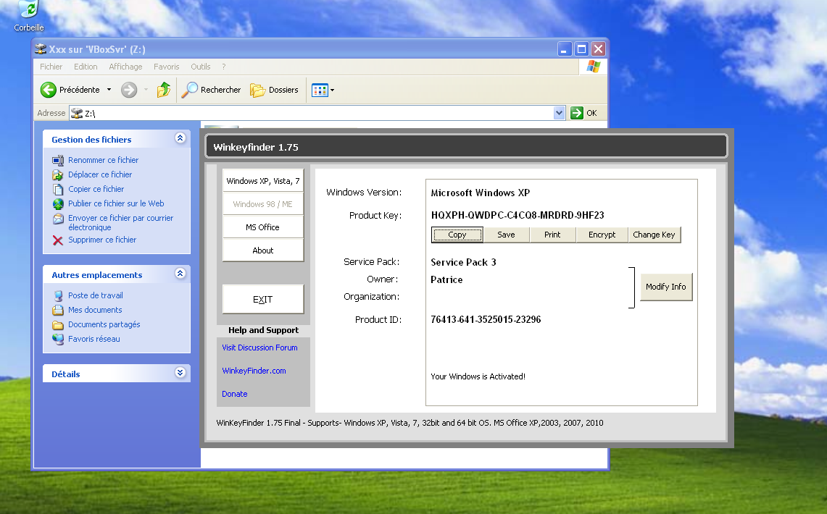
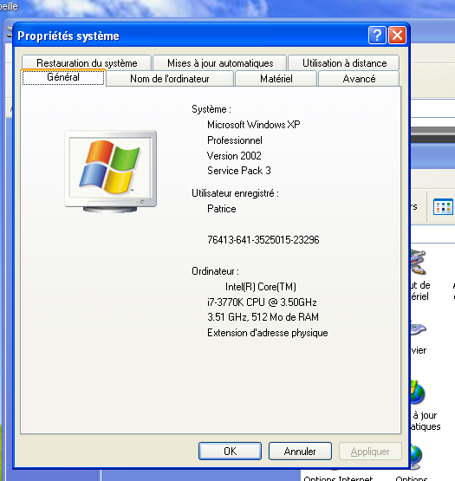

heqg3yp

